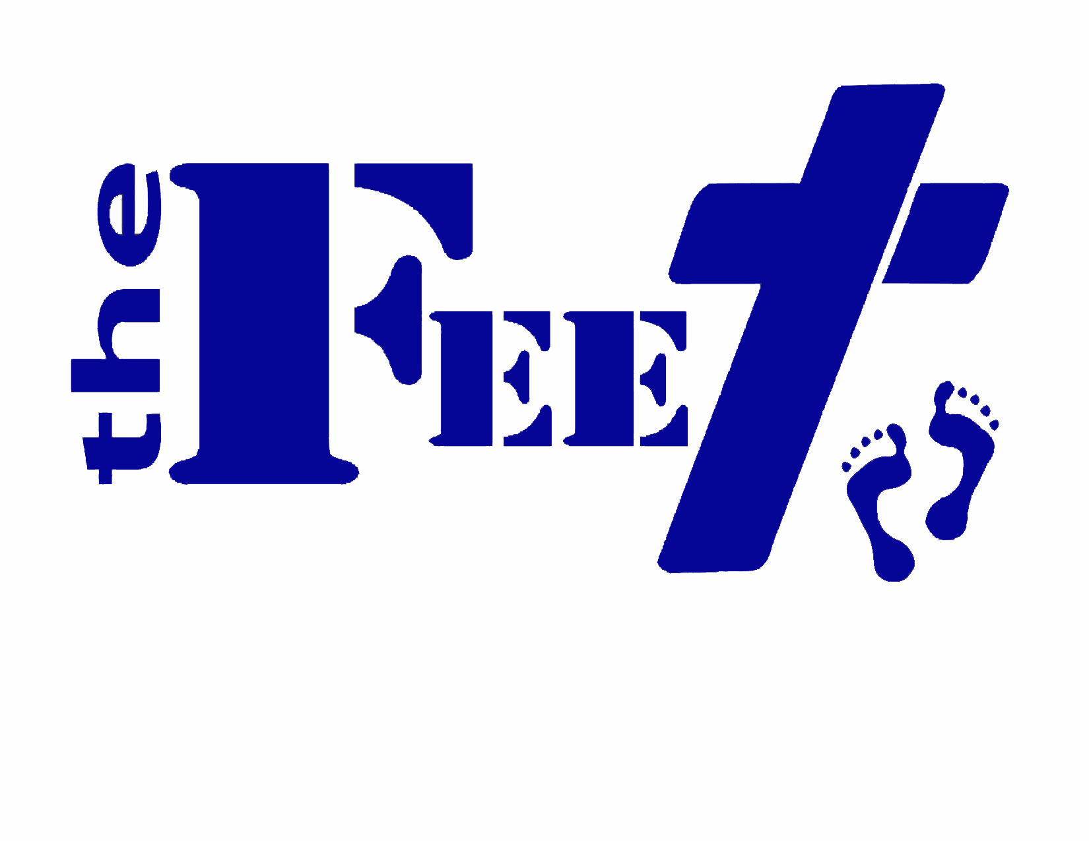

Beautiful Feet Ministries Discipleship Program

Program Rules
(Your successes and failures are found in your daily routine)

- Follow the Golden Rule, “Do unto others as you would have them do unto you.”
- No foul language, taking horseplay too far(coarse joking), or fighting.
- No usage or possession of drugs, alcohol, or tobacco of any kind in or off the premises.
- Theft of any kind by residents of the restoration house is not tolerated.
- Keep your room, bathroom, kitchen, living areas, and yourself clean at all times. Shower, brush your teeth, and shave every day. Additionally, laundry must be washed and put away.
- Make your bed and do assigned chores daily. You must be out of bed by 5:45 a.m.; make your bed and get dressed immediately.
- Lights on/out times must be followed: 10:30 p.m. on weeknights, 12:30 on Fridays and Saturdays.
- You must attend and arrive to all church services on time; notes must be taken and turned in after services.
- Cook dinner for the others at assigned times each week.
- Maintain a job and tithe every week(to a church body of your choosing) when you start having supervised access to your money after the first phase of the program. (approximately 3 months). You must perform the work we provide until you graduate.
- After a resident has graduated and finish 1ed the year-long commitment, they will be required to pay rent of $200 a month; with an increase of $50 every 2 months until you reach a cap of $400(this covers rent, food, and utilities.)
- Complete goal assignments, budgets, and exit plans.
- Remain obedient and submissive to authority, at home and at work, no murmuring or complaining PLEASE.
- Have a good attitude towards everyone, no disrespecting others. Take up offenses one on one with brotherly love. One on one requests cannot be ignored over a 24 hour period
- If anyone offends you, you need to talk to that person one on one in a private area; deal with it like a man. But be sure to pray about the situation first and pick and choose your battles.
- You agree to be involved with a good and positive attitude towards all outings, dinners, family nights, and mission trips that are mandatory and scheduled.
- No dating while living at Beautiful Feet-
Dating is viewed as follows: having a one on one conversation with the opposite sex that is intimate or emotional; riding in a vehicle alone with someone of the opposite sex; texting, letters, or making phone calls; sitting next to each other in church or outings, etc.
- Phone calls and visitation is regulated after 60 days.
- No computer access until you have permission by the director.
- Random drug testing will be given and consented to without resistance.
- Christian music is the only music we let into our gates (ears)
- PG-13 movies only- no rated R movies are to be watched.
- Turn in your cell phone to the director until 6 months or a decided time by staff and the director.
- Serve at church every Saturday until month 3.
- After 6 months you will be able to have a day OR hourly pass to go do personal things with accountability and restrictions, such as drug and alcohol testing. You will be responsible for your own rides.
- Movies on Friday nights, Saturday, and Sunday afternoons only.
- Wear collared shirt tucked in on Sunday. No hats allowed in sanctuary.
- Ask permission from director or supply person for clothes, food, and hygiene supplies.

Failure to comply with any of these rules will not be tolerated. Pastor Mike Myers and the discipleship director will determine expulsion from home at any time.

If you break any rule and do not confess within 24 hours to staff member, you are subject to dismissal from the program. This program is for your benefit, and honesty will have lesser consequences than staff finding out.

- I understand that this is a work program and work will be required of me. Any issues (physical, mental, medical, etc.) hindering my ability to work could result in expulsion from the discipleship and the work program. An attempt will be made by Beautiful Feet Ministries to find a program that will accept the program applicant, though no guarantee is expressed or implied. I will not hold Beautiful Feet Ministries or Hearts and Hands 4 Him liable of discrimination and free these entities from suit. I agree to Hearts and Hands 4 Him withholding wages earned for any uniform items I keep after expulsion or my willful exiting of the Discipleship program.
- I agree that my pay for the last month I work for Hearts and Hands 4 Him will only be paid via direct deposit into my account, and I will not be given a check at the time of my exiting program. The Pay period is every two weeks.
- I am here because I want to change my life and am seriously committed to do whatever it takes to do so.

Signed: ___________________________ Printed Name:_______________________________

Director’s Signature: __________________________ Date: ____________________________________

